Welcome to White Lily Casino!

Here is a user guide to help you get started :

**Getting Started**

Firstly, you’ll want to **create an account** using the “create user” button so that you can use our facilities. Passwords are case-sensitive so don’t forget them!

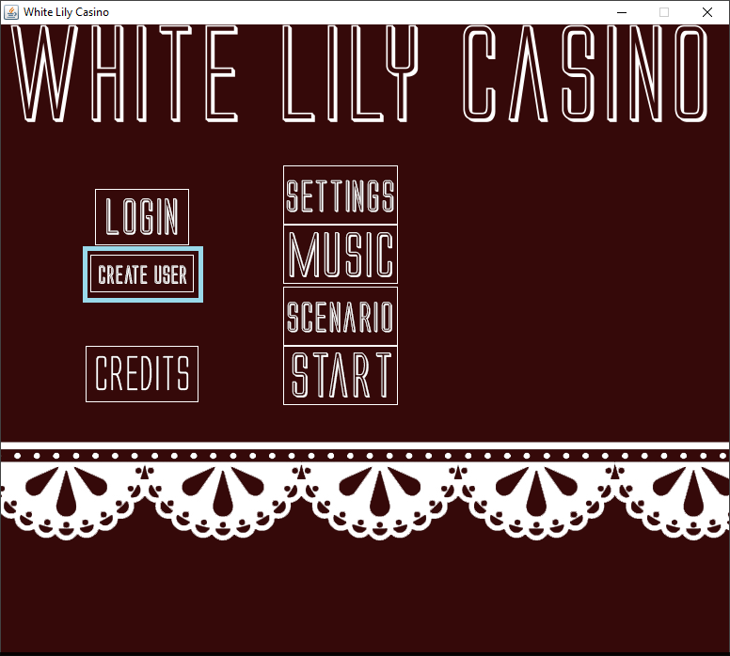

After you’ve created an account, you may **log in**. You will start off with $10,000. (Ten-thousand dollars).

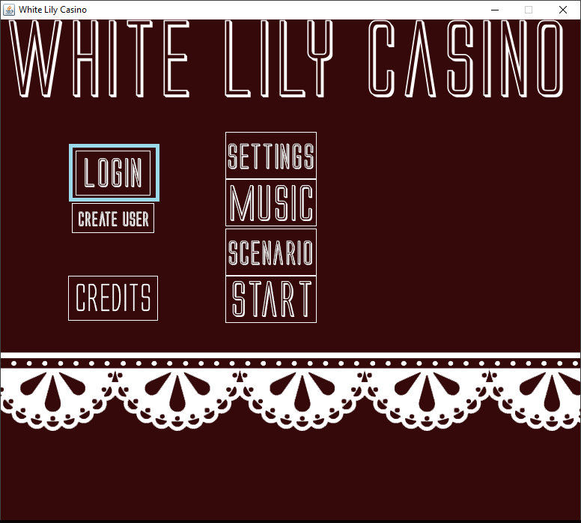

You may **view your statistics** by clicking on any of the buttons on the bottom screen. Additionally, you may take out a loan if you’re out of money. But be cautious, because after you’ve taken out at least $100,000,000 (One hundred-million dollars), **you will no longer be able to take out loans** until your debt is less than or equal to $99,999,999. (Ninety-nine million, nine-hundred ninety-nine thousand, nine-hundred ninety-nine dollars)

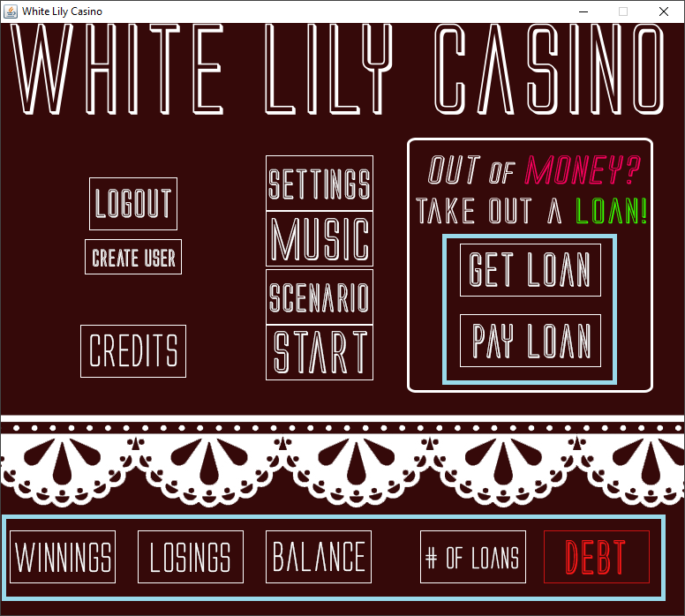

If you’re not a fan of the main menu audio, you may press the music button **toggle** (enable /disable) it.

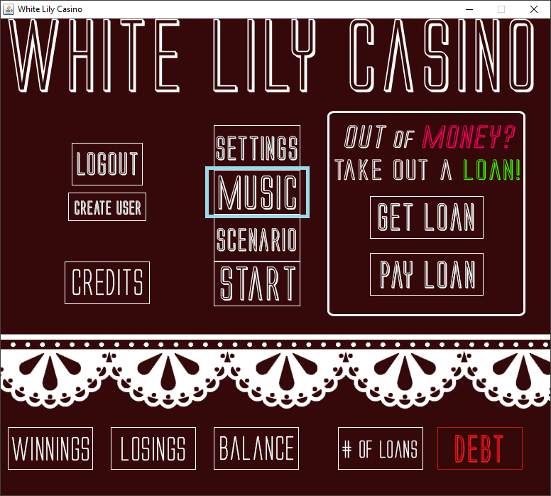

**Gambling**

White Lily Casino is a new White Lily Facility. Being such, it has limited options for gambling though the ones it does provide are guaranteed to satisfy you. To play Blackjack, Navigate to the game menu by pressing **Start ->** and then clicking on **Blackjack ->** to start.

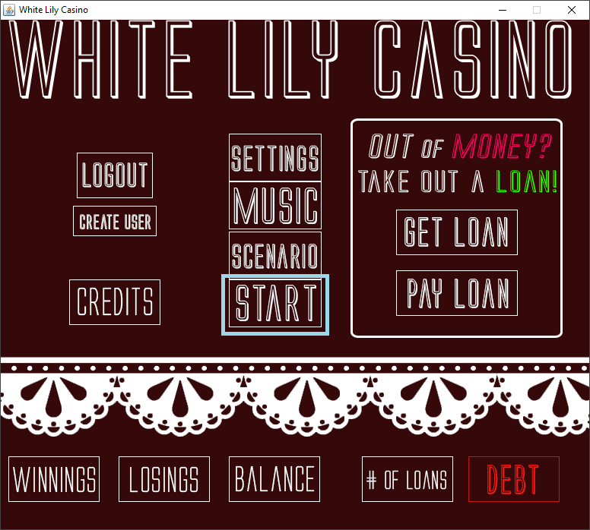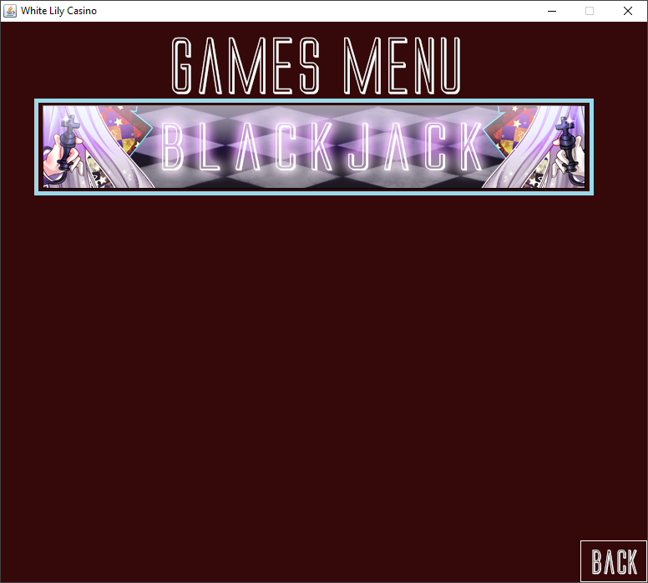

The **rules** of Blackjack are available via the rules button on the **Blackjack user interface**.

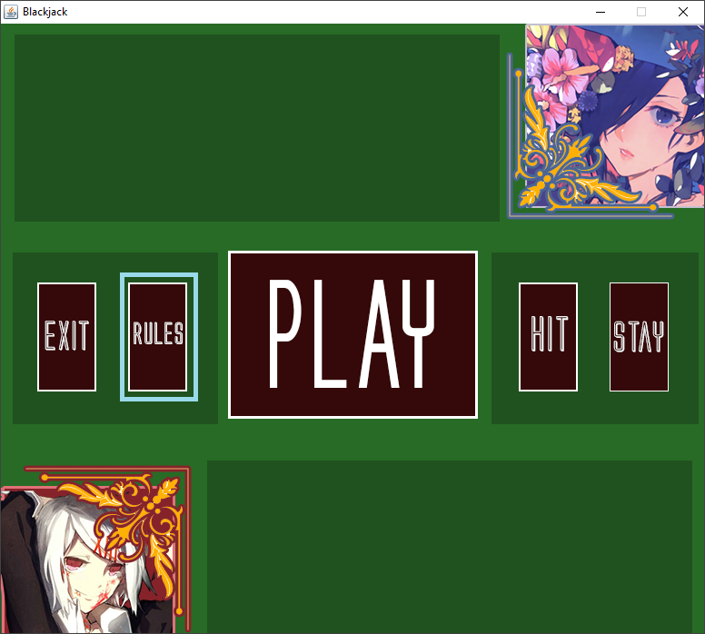

You, the player have the chance to win 150% of what you put in. For example, if you bet $100, the pot (what you have the chance to win) is $150. You may bet anywhere from $1 to $1 quadrillion (If you have that much). You may not exit Blackjack while a game is in session.

**Shortcuts**

If you don’t feel like typing in 1000000 to bet $1 million or 1000000000 to bet $1 billion you can use the nifty naming conventions provided below :

|  |
| --- |
| K or k - thousand (i.e. 1k is a 1000 or $1 thousand bet with a pot of $1.5k)  M or m - million (i.e. 1m is a 1000000 or $1 million bet with a pot of $1.5m)  B or b - billion (i.e. 1b is a 1000000000 or $1 billion bet with a pot of $1.5b)  T or t - trillion (i.e. 1t is a 1000000000000 or $1 trillion bet with a pot of $1.5t)  Q or q - quadrillion (i.e. 1q is a 1000000000000000 or $1 quadrillion bet with a pot of $1.5q) |

The team at White Lily Casino wishes you luck on your endeavors at our Casino and hope that you enjoy our facilities responsibly